**Integrate Kubernetes(EKS) and logs with New-Relic**

**Pre-requisites:**

* EKS-Cluster
* New-Relic Account

New-Relic Account:

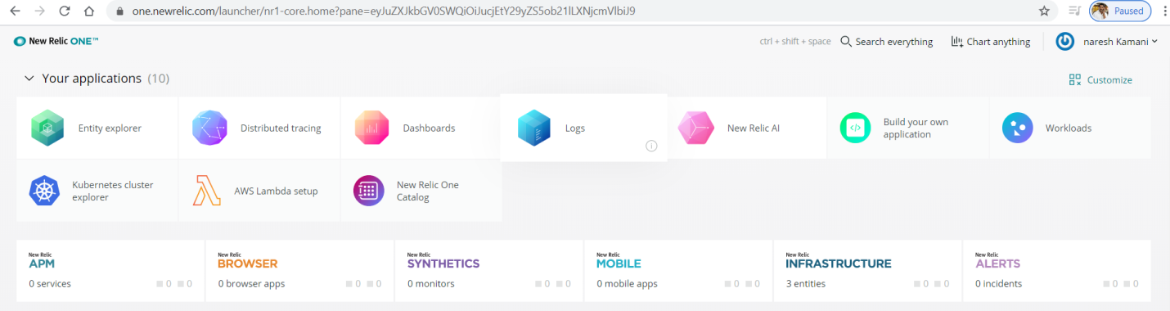

EKS-Cluster:

Here my cluster name is **eks-cluster** with two nodes



**New Relic license key**

Follow below steps how to copy new relic license key

Goto new-relic UI



Click on dropdown

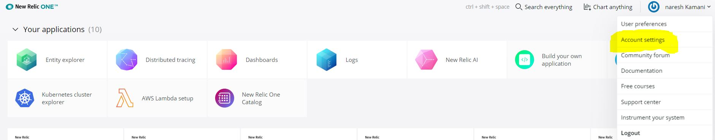

Click on **Account settings**

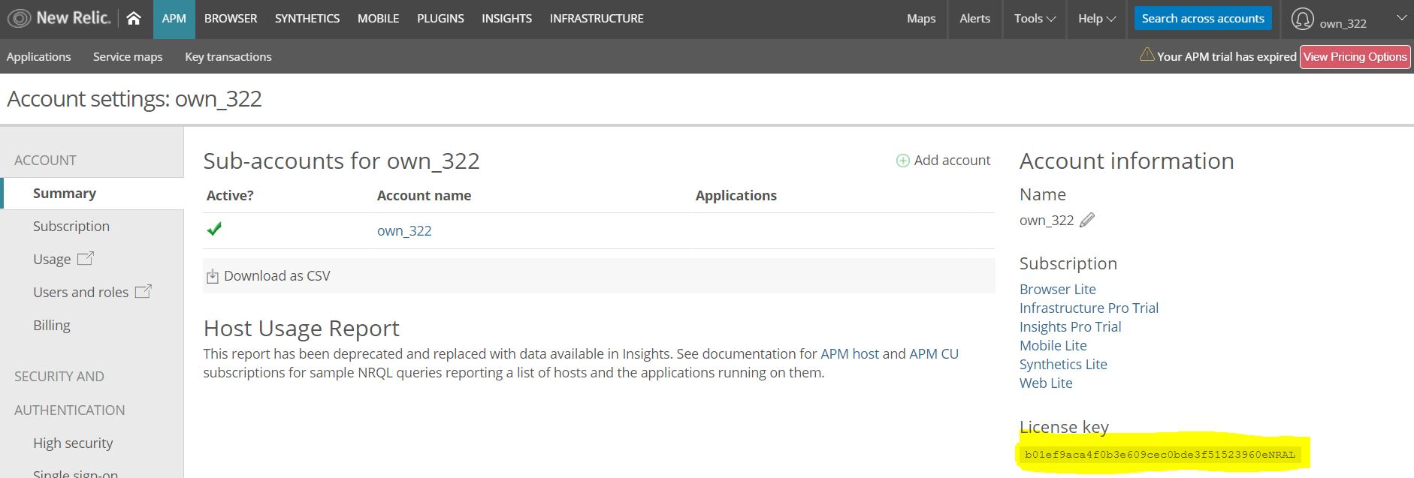

Copy This License key

**Kubernetes plugin for Logs:**

New Relic offers a Fluent Bit output plugin to connect your Kubernetes cluster log data to New Relic Logs.

Compatibility and requirements:

To use New Relic Logs with the Kubernetes plugin, ensure your configuration meets the following requirements:

* New Relic license key
* Kubernetes cluster deployed

Install the Kubernetes plugin:

Clone kubernetes-logging

git clone <https://github.com/newrelic/kubernetes-logging.git>

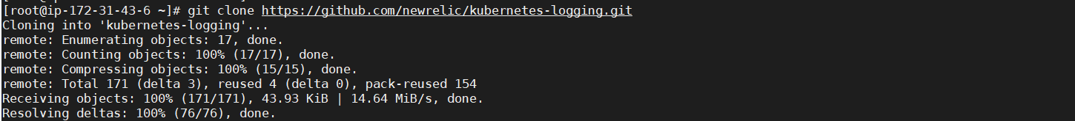

Configure the Kubernetes plugin:

To deploy your Kubernetes plugin:

cd kubernetes-logging/

In the downloaded new-relic-fluent-plugin.yml file, replace the placeholder value <LICENSE_KEY > with your New Relic license key.

vi new-relic-fluent-plugin.yml



Once the License key has been added, run the following command in your terminal or command-line interface:

kubectl apply -f .



**Install Kubernetes integration:**

This section explains a standard Kubernetes integration install. For other options, including installing on a managed platform, see Install overview.

To activate the Kubernetes integration, deploy the newrelic-infra agent onto a Kubernetes cluster as a daemon set:

1. Install kube-state-metrics and get it running on the cluster. For example, for the latest supported version, 1.7.2:

curl -L -o kube-state-metrics-1.7.2.zip https://github.com/kubernetes/kube-state-metrics/archive/v1.7.2.zip && unzip kube-state-metrics-1.7.2.zip && kubectl apply -f kube-state-metrics-1.7.2/kubernetes

1. Download the integration configuration file:

curl -O <https://download.newrelic.com/infrastructure_agent/integrations/kubernetes/newrelic-infrastructure-k8s-latest.yaml>

1. In the configuration file, add your New Relic license key and a cluster name to identify your Kubernetes cluster. Both values are required.

vi newrelic-infrastructure-k8s-latest.yaml

env:

- name: "CLUSTER_NAME"

value: "eks-cluster"

- name: "NRIA_LICENSE_KEY"

value: "b01ef9aca4f0b3e609cec0bde3f51523960eNRAL"



1. Confirm that kube-state-metrics is installed.

kubectl get pods --all-namespaces | grep kube-state-metrics



1. Create the daemon set:

kubectl create -f newrelic-infrastructure-k8s-latest.yaml

1. Confirm that the daemon set has been created successfully by looking for newrelic-infra in the results generated by this command:

kubectl get daemonsets



To check pods:

kubectl get pods

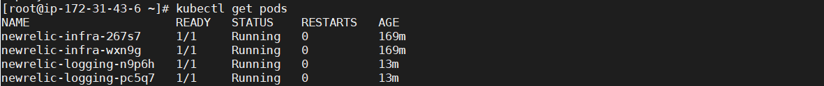

To confirm that the integration is working: wait a few minutes, then look for data in the New Relic Kubernetes cluster explorer.

Goto New Relic and check

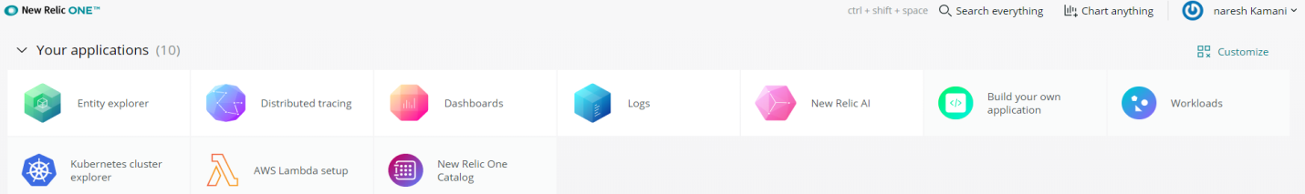

Click on Kubernetes cluster explorer

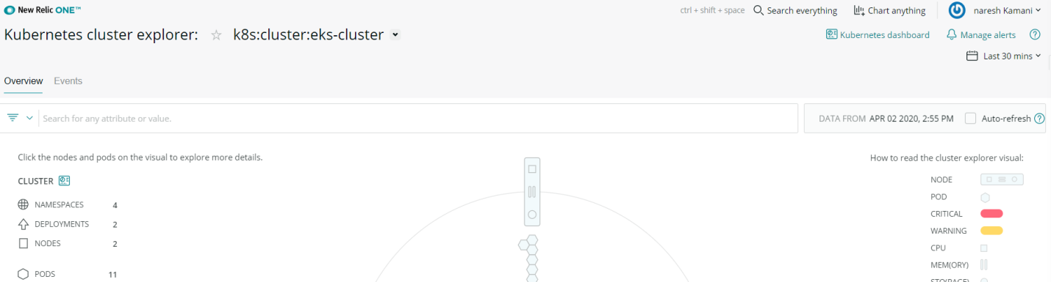

Deploy HelloSpringEKS application:

Clone application:

git clone https://github.com/Naresh240/HelloSpringEKS.git

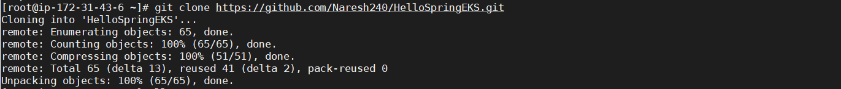

cd HelloSpringEKS/

kubectl create -f HelloSpringEKS.yml



Check pods:

kubectl get pods

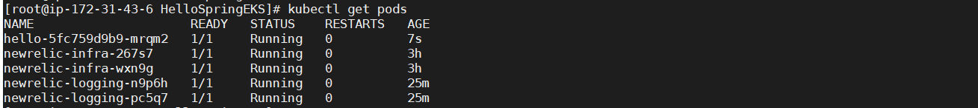

Check in new-relic webUI:

To check pods here

Click **Kubernetes cluster explorer** on new-relic webUI

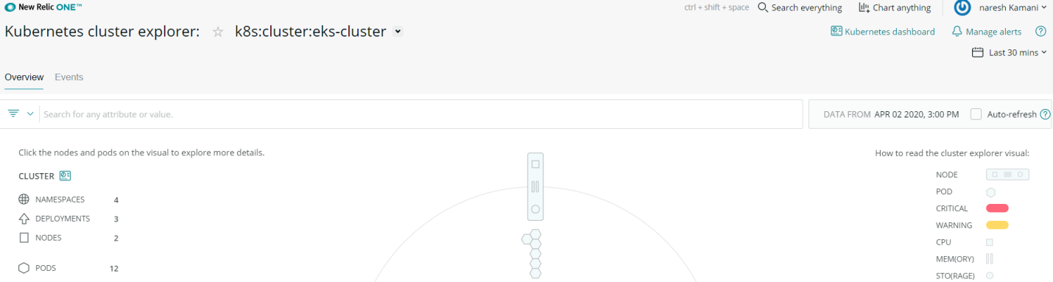

To check logs

Click on **logs** on new-relic webUI

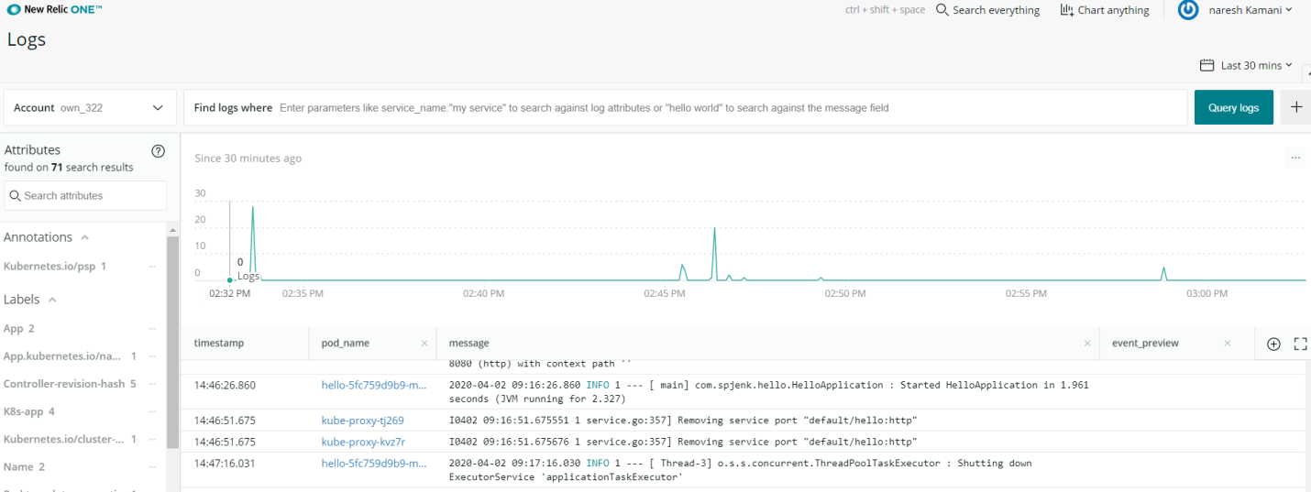

Here we can Query logs